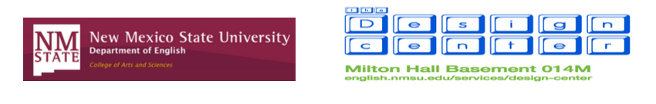

Girlhood Remixed Technology Camp 2015
Consent Form
The Girlhood Remixed Technology Camp was designed not only to offer young women in southern New Mexico experience with digital tools and online identities, but it is also part of ongoing outreach and future after-school workshops and summer camps. As such, it can be useful to share the work created by campers in this Camp with grant-awarding organizations and in scholarly venues. Throughout Camp we plan to take photographs and film the girls in “interviews” discussing their experiences. This documentation will allow us to share curriculum, planning, and reflections from this Camp with future campers and other teachers and scholars interested in organizing similar events.
Campers’ Role:
Those campers who feel comfortable sharing their work and being photographed and videotaped – for scholarly and grant purposes only – should have their parents/guardians sign below granting permission to reproduce and share work and images of campers taken during regular camp activities. Campers and their parents can provide consent in one of three ways: grant permission to use image and work with a name and identifying information, grant permission to use image and work without a name and identifying information, or deny permission to use image and work.
Campers’ Information:
Depending on what information campers feel comfortable sharing – if any – Jen England will collect videos, images, and work they create during Camp. Throughout Camp, our intern Anthony will post to the Camp website with updates and news about Camp. The website may also be used for research purposes if campers feel comfortable granting permission to do so.
Participation is Voluntary:
Again, granting permission for campers’ images and work to be shared is completely voluntary and will have no bearing on the campers’ ability to participate in this Girlhood Remixed Technology Camp or future events offered by the New Mexico State University English Department or Design Center. However, each camper must provide a signed consent form explaining what sort of permission she feels comfortable granting. If you have any questions about the possible future use of your camper’s work, please contact Jen England at jengland@nmsu.edu.
Thank you for your consideration,
Jen England
Consent Form

Camper Information
Camper’s Name: ________________________________________________________________
Age: ____________ Hometown: __________________________________________________
Grade in School: ________ School Attending: ________________________________________
Signature for Consent
Please choose whether you wish to grant permission for your child’s image to be taken and to share your child’s work. There are three options for consent: [1] grant permission with name and identifying information (provided above), [2] grant permission with no name and no identifying information, or [3] do not grant permission. Please sign and date only one choice of consent.
Consent Option 1
I grant permission to share my child’s image and work with her name and identifying information.

_____________________________________________ ______________
(Parent/guardian signature) (Date)

Consent Option 2
I grant permission to share my child’s image and work without her name or identifying information.

_____________________________________________ _______________
(Parent/guardian signature) (Date)

Consent Option 3
I do not grant permission to share my child’s image and work.

_____________________________________________ ________________
(Parent/guardian signature) (Date)

