To Whom It May Concern:

We are seeking donations for the second annual Girlhood Remixed Technology Camp held July 17-19 and sponsored by the NMSU English Department. The camp provides Las Cruces area girls ages 10-13 the opportunity to engage with various digital tools and to create several digital projects that help them question and craft their online identities.

The camp will work to overcome the gender, economic, and cultural digital divides that negatively—and disproportionately—impact many of the area’s students, especially young women. We want this camp to be a space for critical and creative activities, and therefore are in need of some basic necessities. In particular, we need to feed our 24 campers as well as 4-6 volunteer teachers during our three-day camp:

- Eight full meals (three breakfasts, three lunches, and two dinners)
- Snacks and other munchies
- Drinks and bottled water

If you would be able and willing to donate any food or other items in any amount, we would be greatly appreciative. All donors will be listed as co-sponsors of the camp in the camp’s closing ceremony program, which the girls will design themselves. Donors will also be named in any PR-related materials. We expect coverage from NMSU media and the Las Cruces Sun-Times.

Should you have any questions or would like additional information, please don’t hesitate to contact us.

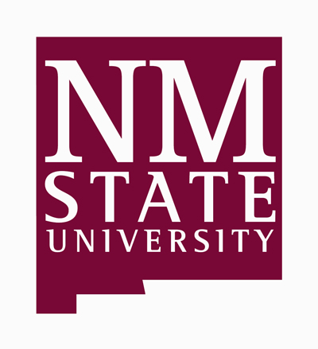
Thank you for your consideration,

Jen England, Assistant Camp Director
419-571-2296
jengland@nmsu.edu

Dr. Jen Almjeld, Camp Director
419-308-7504
jalmjeld@nmsu.edu

