GarageBand Concepts
-Open new project (click on new project, top left of screen, choose the podcast option and name your project)
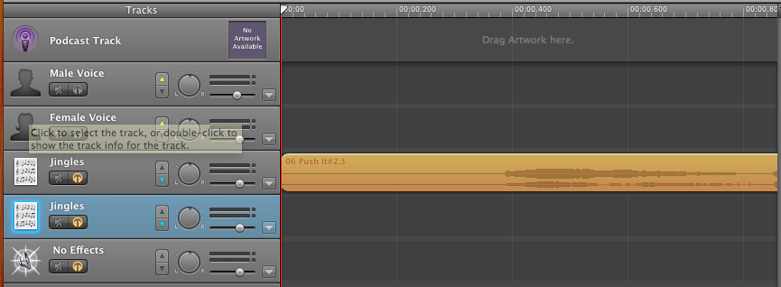

Navigation buttons are located at the bottom, center of your new project.
They are •Rewind •Fast forward •Go back to the beginning •Play and Stop •Record)

-Record voice option
-(We won’t need it for our project) – Choose one of the female or male voice tracks – though it doesn’t really matter. Hit the red button at the bottom of your screen to record and hit it again to stop recording.)
-If you want to cut part of what your record or you make a mistake you choose the point where you want to start the recording and then go to “Edit” and choose “split” – that lets you delete what you want, cut it, move it, etc.

-Find music
Another set of navigation buttons you need to know is:

• The eye lets you find special effects, jingles, etc.
• The “i” gives you instruments – and loops you can use for background music
• The button with a piece of film, music note, and photo box gives you access to music in your iTunes, photos in iPhoto and any videos you have stored
-If you own songs you can drag them into an empty track space and split them and move them just like you can your own recorded material

-Find special effects, sounds
-GarageBand also gives you some sounds.
-Hit the “eye” button and you should get a list of All Effects, Jingles, Stingers, etc.
-Preview them by clicking on them twice at the bottom of the screen
-When you find one you like, click and hold on the name of the sound effect and drag it into your “jingles track”
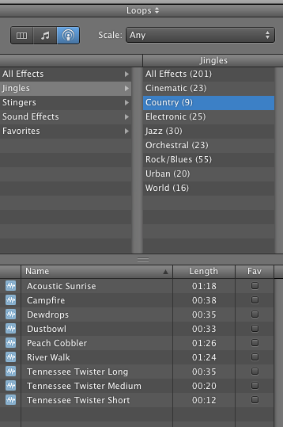
-Cut, split, arrange tracks to tell your story
-Find the “Edit” menu at the top of the screen. Go to the point in your track that you want to keep more move and place your curser. Then, under “Edit”, find “Split.” This turns your audio file into two pieces so you can delete what you don’t like or move the pieces.
-To move sounds, simply click and hold and drag them where you want them in their existing track or into another track.

-Making new tracks
-A new project provides you with only four open tracks. To add more, go to the “Track” menu at the top of the screen and either choose “New Basic Track” or choose a track you already have, click on it, and choose “Duplicate Track.”

-Controlling playback
-Sometimes you will want to hear just one track, so GarageBand gives you the option of hearing the track or muting it.
-Each track has this button: The horn with the strikethrough mutes your sound and the orange arrow lets it play.

-Save your genius creation
-Once you have your project just right, go to the “Export” menu where you can save your work directly to iTunes, or save it to your desktop by choosing “Export Podcast to Disk.”

-Finding more sounds
-Some sites on the internet help you find sounds GarageBand doesn’t provide. Check out http://www.findsounds.com/
-To save files on a Mac, hold down control key and click on link, choose save link as to save to desktop.

