Getting Started with iMovie

iMovie is film editing software readily available on BGSU's campus as well as in any new Macintosh computer start-up software package. With very minimal instruction, it is possible to create short films incorporating video, audio, text, and still images to tell stories. This format is ideal for exploring the potential of multi-modal and visual literacy in our world and many students may welcome the chance to augment a traditional textual essay with this type of technology.
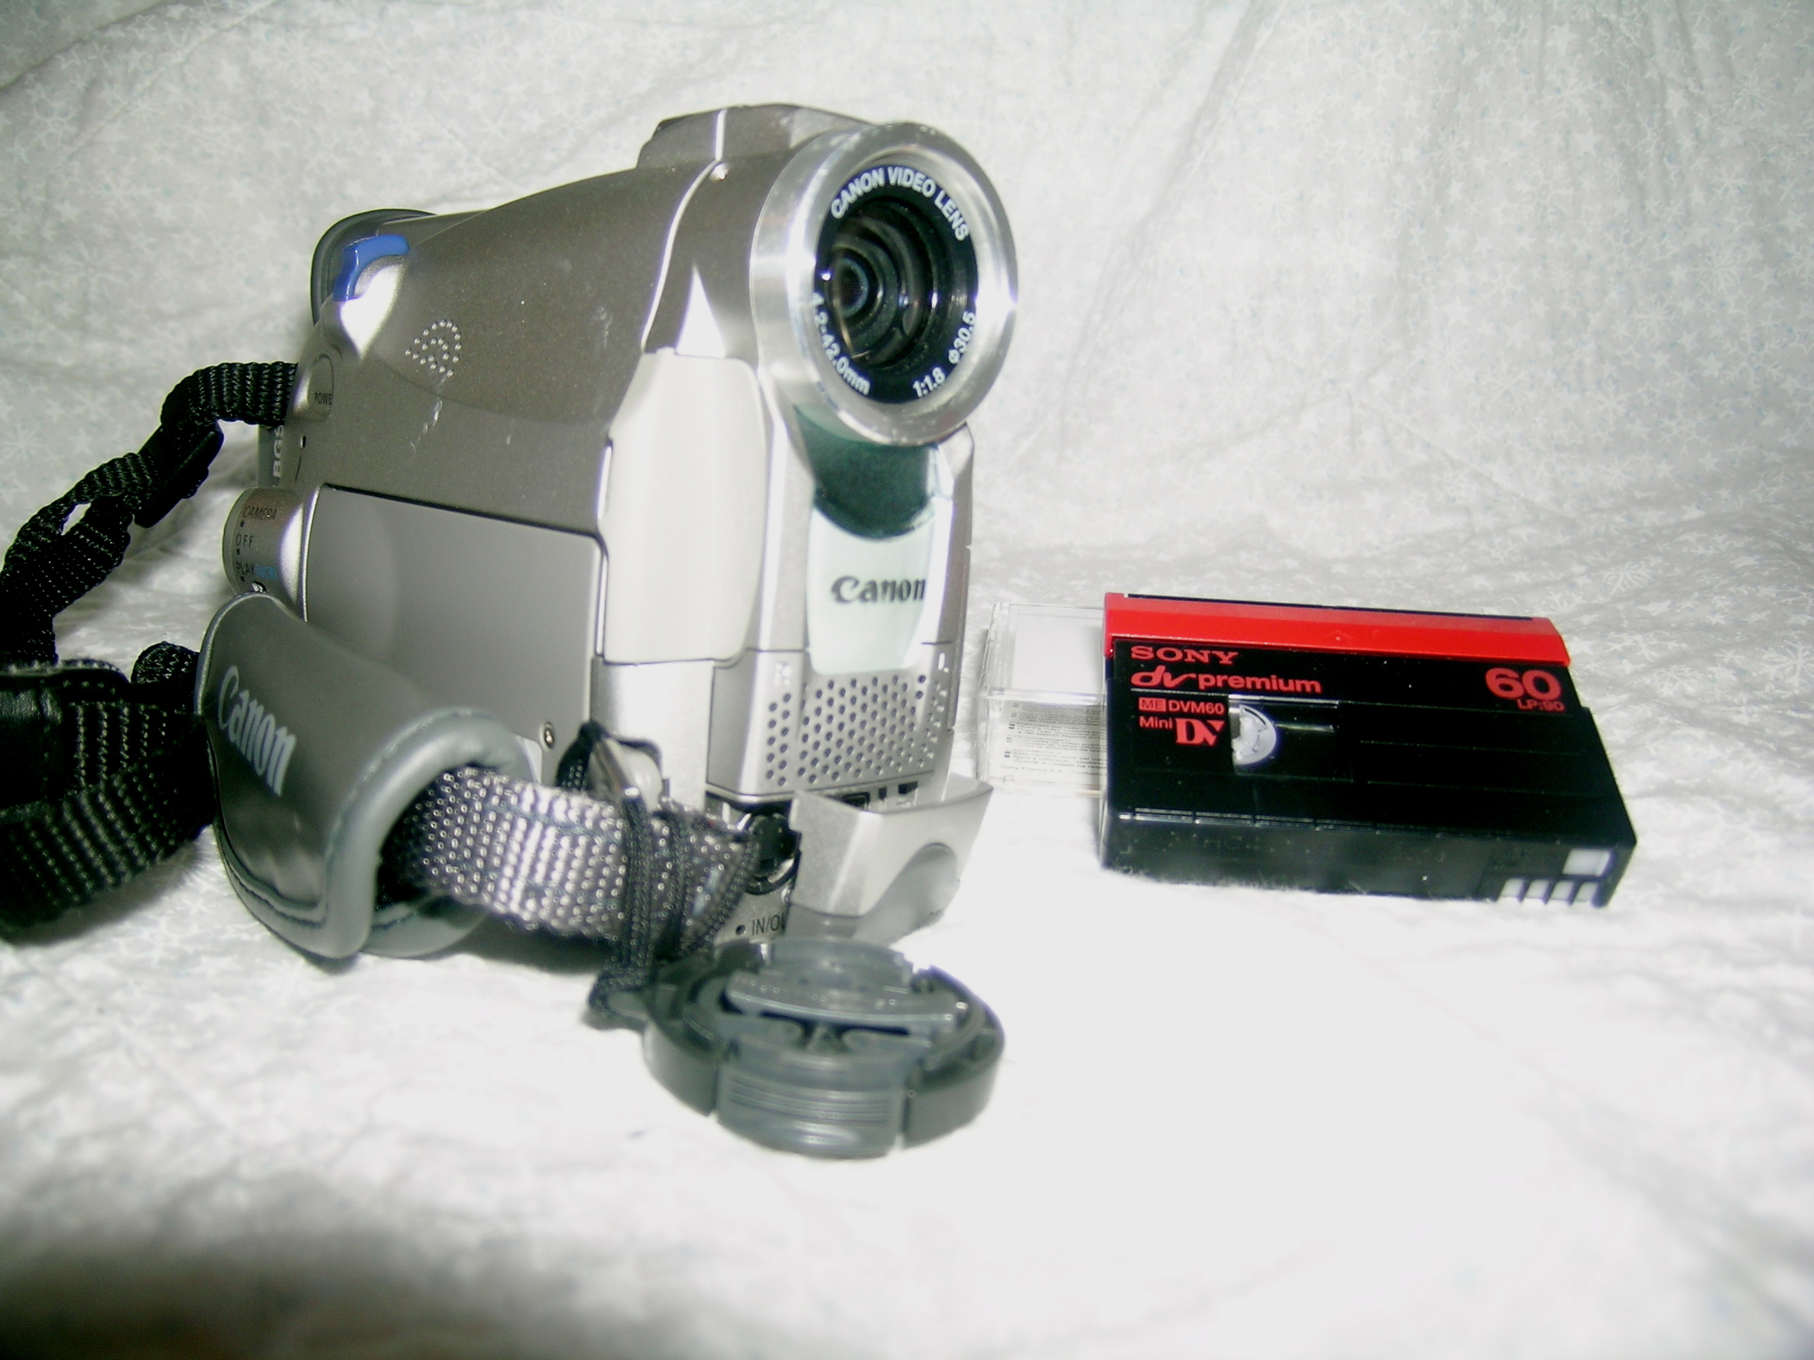
Going to the tape
•Students may sign out video cameras from the Student Technology Center for three days. For information, call
372-9277 or go to www.bgsu.edu/offices/
studenttech. Faculty should contact Information Technology Services to borrow equipment. For information, call 372-2911 or go to www.bgsu.edu/its/index.
•Each camera comes with a manual and lab personnel can provide basics for getting started once the video camera is picked up.
•Each student must purchase a mini-video cassette before beginning their project.
•Since film files are so large, it is also advisable that students check out a Firewire hard drive along with the camera equipment. In most cases, Firewire drives may be checked out for two weeks.

Getting Started with iMovie (cont.)

Once students have taped footage for their project, have them download the footage they wish to use in their movie to the computer via the iMovie software.

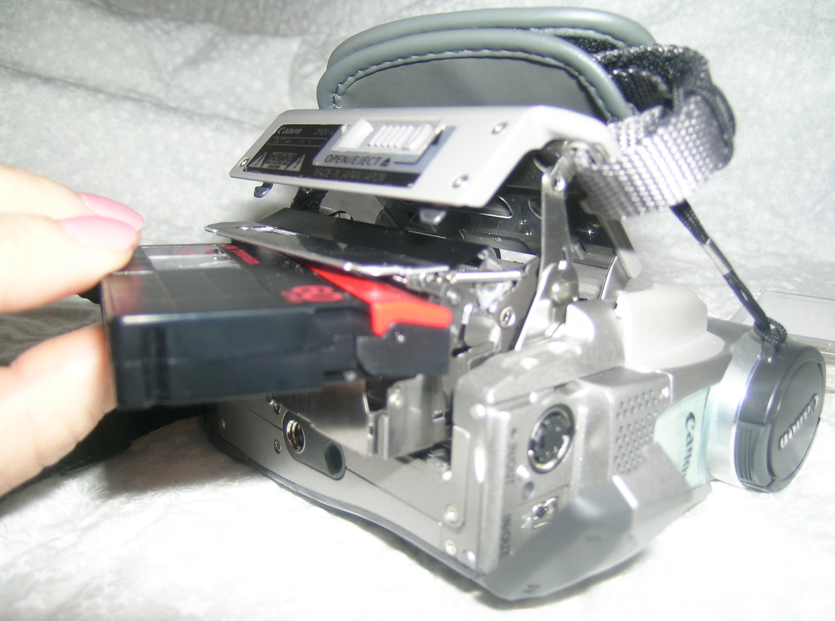
Connecting the camera
•Load tape into video camera.
•Make sure computer is on and iMovie is open.
•Switch camera to play mode (VCR) at the "Power" button.
•Find the included chord to connect the video camera to the computer.
•Attach the chord to the computer at a driver port where you would plug in a jump drive.
•Attach the chord to the video camera at the in/out port located under the lens of the video camera.
•At this point, the screens of both the video camera and computer should be blue and read "Camera Connected."
•Go to iMovie and under the File menu go to "New Project."
•Name the new project and save it to the desktop.

Finding iMovie controls

•Locate iMovie control buttons under main screen. •Next to the control buttons, make sure setting is on camera (for viewing) and not scissors (for editing).


Getting Started with iMovie (cont.)

Students will obviously record more footage than needed and so should preview their tape to see what clips they might like to use in their project. iMovie or the video camera controls can be used to preview video. Storyboarding may be useful at this stage depending on the complexity of the final project.

Selecting footage
•Clips of film are imported to the computer from the camera by hitting the "Import" button below the main screen.

•Film will transfer until the "Import" button is chosen again or until you choose the "Stop" button.

•Suggest that only small amounts of film by imported at a time. Most clips will only be 10-15 seconds long at most.

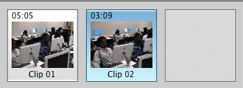
•Once film has been imported it will show up as a series of clips at the right of the main screen of the iMovie program.

Editing with iMovie

After downloading footage, students are ready to edit clips and arrange them for use in their finished movie.

Begining to edit
•Switch button from camera to scissors to begin editing.
•Notice that the control buttons below the main screen change to allow for editing.


Go to beginning of clip Play View clips in full-screen mode

Selecting clips
•Click on the clip you want to edit.
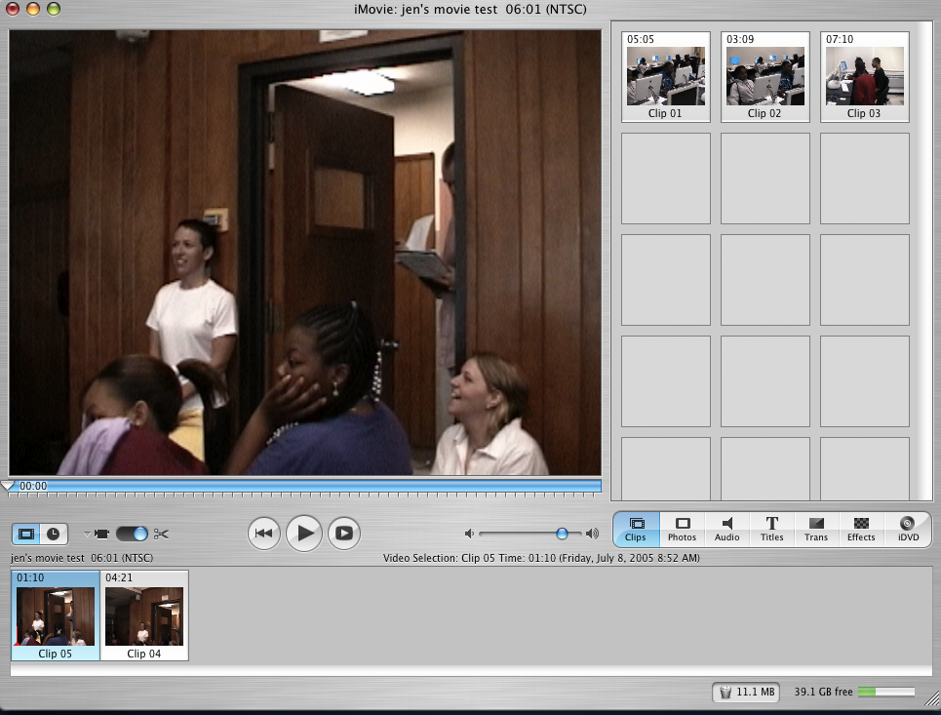
•Once you have chosen a clip from those stored on the right side of the screen, it will appear in the main frame so you may begin editing.

Editing with iMovie (cont.)

Editing clips
•Cut clips by moving tick marks underneath the main iMovie frame.

•Set tick marks so that they bracket the piece of the clip you wish to keep (All film visible above the yellow portion of the editing bar will remain).
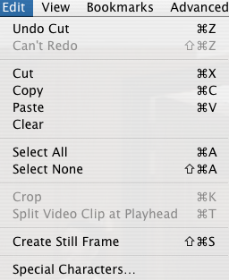
•Go to the Edit menu in the menu bar.
•Select "Crop."

Arranging clips
After editing clips, sequence them for the final film that will be constructed at the bottom of the iMovie screen.

•Click on desired clip and drag it to the bottom of the screen.
•Once all clips have been placed in desired locations in the movie, experiment with sequencing by clicking on a clip and dragging it to a different position in the bar.
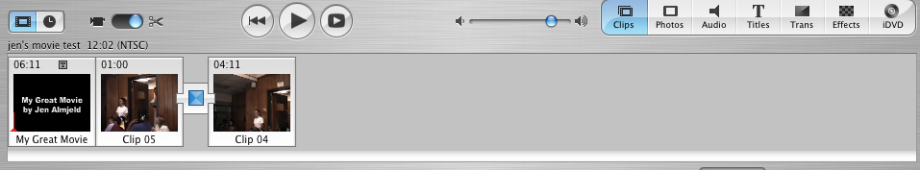

Editing with iMovie (cont.)

Adding transitions and title screens allows students to incorporate text into their visual compositions. The act of selecting images, ordering them, and augmenting them with words is as much a rhetorical act as writing an essay and offers students, especially tech-savvy students, a new way to look at composition.

Selecting transitions
•Choose a clip that you would like to test a transition on.

•Click on the "Trans" button at the options bar underneath the clips display screen.
•A list of possible transitions will appear at the top, right side of the screen.
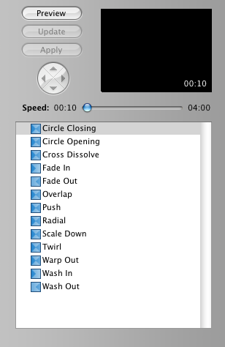
•Choose a transition to preview.
•Hit the "Preview" button to see the effect in the large screen at the left.

Adding transitions
•Choose a transition and add it to the final film by clicking and dragging it from the listing at the top, right of the screen to the sequence of clips at the bottom of the screen. •Place the desired transition before the clip you would like it to affect.

Adding Titles in iMovie

Adding titles
•At the options bar, choose the "Titles" button.

•Type text in the blank title bar as seen below.


•Choose from the Title Effects menu.
•Select the "Preview" button.
•Add a title by choosing an effect and clicking and dragging the title into place in the final film strip at the bottom of the screen.

iMovie for Field Research

Because ENG 110, 111, and 112 include a portfolio review as a requirement for completing the courses, it is impossible to allow students to submit a composition in video format only. Video can be an important part of class time, however, as a starting point for a traditional textual paper. iMovie makes a wonderful research tool as students are narrowing down their topics for essays.

Using iMovie research in ENG 110 and 111
•In most 110 and 111 classes, five essays are done in the semester in the following formats: Making an Argument (2 papers), Searching for Causes, Proposing a Solution, and Justifying an Evaluation.
•iMovie might be a useful heuristic tool for papers dealing with trends on campus or demonstrating local problems.
•Instructors may assign iMovie field research as a precursor to students' writing about searching for causes of trends or phenomenon on campus or in the community. Students could make a short film documenting the trend they wish to explore.
•iMovie might also work particularly well for Proposing a Solution essays as students could use film to identify and document the problem they wish to discuss in their papers.

Using iMovie research in ENG 112
•Most 112 classes produce four essays for portfolio review in the following formats: Critique, Multiple Source Essays 1 and 2, and a Researched Essay.
•iMovie might be especially useful in allowing students to gather their own observations to incorporate with outside sources they will use for longer MSEs and REs.

iMovie for Paper Presentations

GSW instructors often like to have students present their final projects to their classmates. Although students may naturally gravitate toward PowerPoint for such a project, iMovie is an alternative option for presenting final papers.

Presenting iMovies
•For classes that do not normally meet in computer labs, instructors should reserve a lab with a project for presentations.
•Have students present three- to five-minute movies about their topics.

Options for iMovie for Presentations

Some specific presentation options for iMovie in ENG 110 and 111 include:
•For the Searching for Causes essay, have students produce a short film to
demonstrate the trend or phenomenon they discussed in their papers.
•For the Proposing Solutions essay, students should present a short film establishing the problem they attempted to solve in their assigned essay.
•Students might incorporate film from their childhood in an essay focusing on trends or problems faced.

Some specific presentation options for iMovie in ENG 112 include:
•Because topics for Researched Essays tend to vary so widely, students may produce films focusing on problems or trends on campus, in the community, in their hometown, and any other number of possible topics.

Getting Help

Teaching is all about preparing for and handling the unexpected, and teaching with technology only amplifies this challenge. For advice or to deal with equipment, software, and other problems, contact the offices listed below.

Faculty
To reserve computer labs
•Use online forms at www.bgsu.edu/its/labs/reserve.
For software training and assistance
•Contact the Information Technology Services at 372-2911, go to 209 Hayes Hall, or visit www.bgsu.edu/its/index.html.
•Contact the Center for Teaching, Learning, and Technology at 372-6898, go to 201 University Hall, or visit www.bgsu.edu/ctlt/index.html.
For hardware assistance
•Contact the Technology Support Center at 372-0999, go to 110 Hayes Hall, or visit www.bgsu.edu/its/tsc/.
For more teaching ideas utilizing technology
•Contact the Center for Teaching, Learning, and Technology at 372-6898, go to 201 University Hall, or visit www.bgsu.edu/ctlt/index.html.
Students
For online software tutorials
•Contact the Student Technology Center at 372-9277, go to 200 Saddlemire, or visit www.bgsu.edu/offices/studenttech/.
For hardware assistance
•Contact the Technology Support Center at 372-0999, go to 110 Hayes Hall, or visit www.bgsu.edu/its/tsc./
For one-on-one assistance
•Contact the Student Technology Center at 372-9277, go to 200 Saddlemire, or visit www.bgsu.edu/offices/studenttech/.
For online information on operating university video equipment
•Visit www.bgsu.edu/offices/studenttech/dvprogram/index.html.

