iMovie
iMovie is a video editing application that allows people to make their own videos with ease. With iMovie, you can import images, video and audio to create the way you would want to see them.

When first log on to your computer you will click on application at the bottom of your computer, and within the applications you will see a purple star with a filmmaker in the middle. It will be titled imovie. When you do click on it, it will come on your screen like this.
When this pops up on your screen click create.
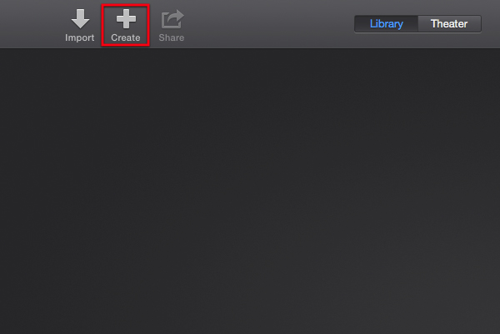

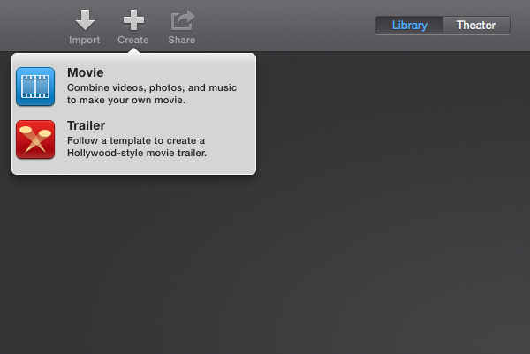
Next, imovie will give you the option to either create a movie or to create a trailer. However, for the project you all will start you will need to click on movie.
Choose a theme.

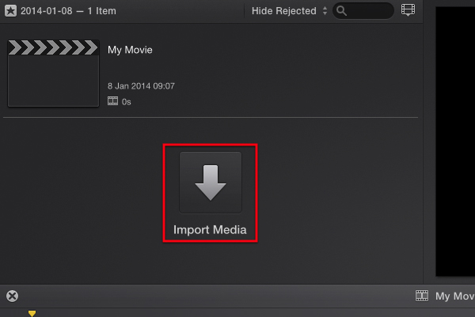
Click Import Media.
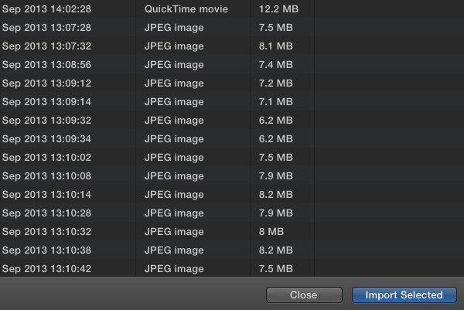
Now, campers will import images that they have either found through the internet or through their cameras, phones, and etc.

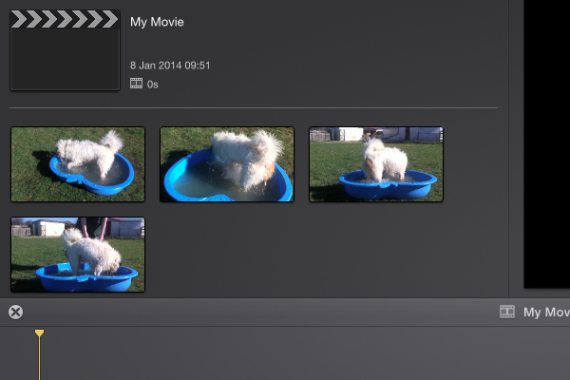
Once you have imported your requested images they will then be stored in the imovie timeline. This is where you will then select your images or other data to create your videos.

After you have imported your images to your timeline you can then drag and drop your media to create your videos!!

Have FUN girls!!!!

