STEP 1: Go to Pinterest.com. Click on the red “Join Pinterest” button.
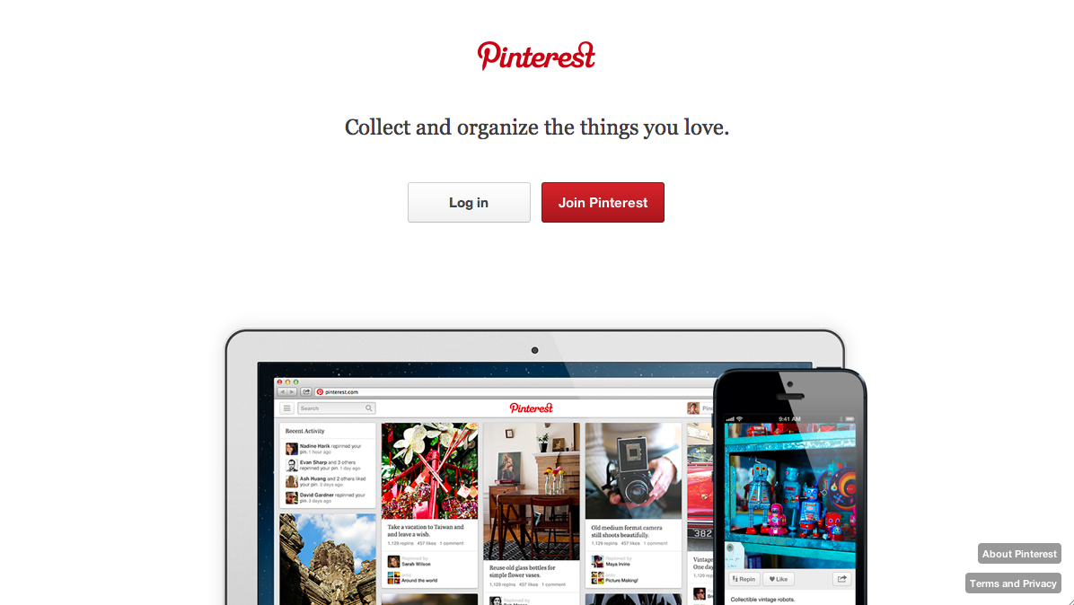

STEP 2: You’ll have three options for creating an account:
- Sign up with your existing Facebook account (which will require Facebook to share your information and install the Pinterest app).
- Sign up with your existing Twitter account (which will require Twitter to share your information).
- Sign up with your email account.

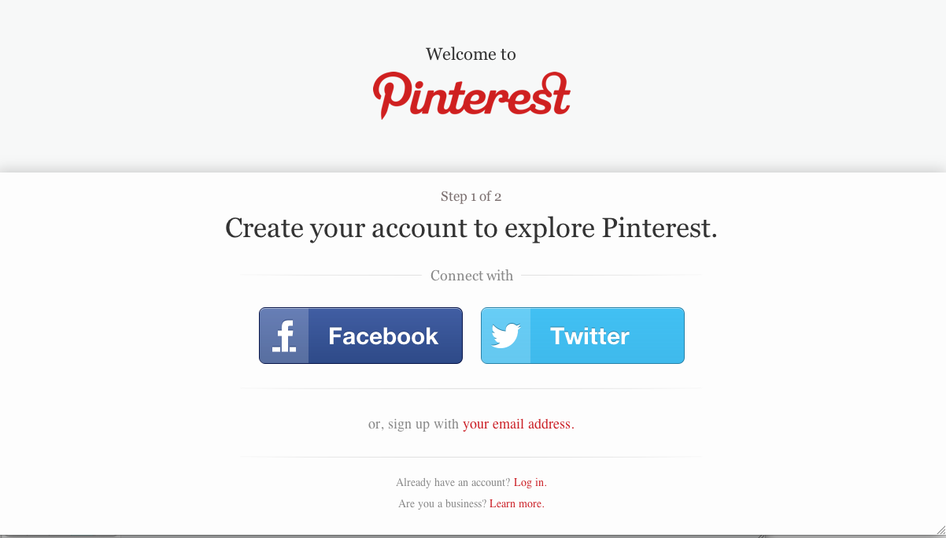

STEP 3: Type in the required information and click the “Create Account” button at the bottom of the page.

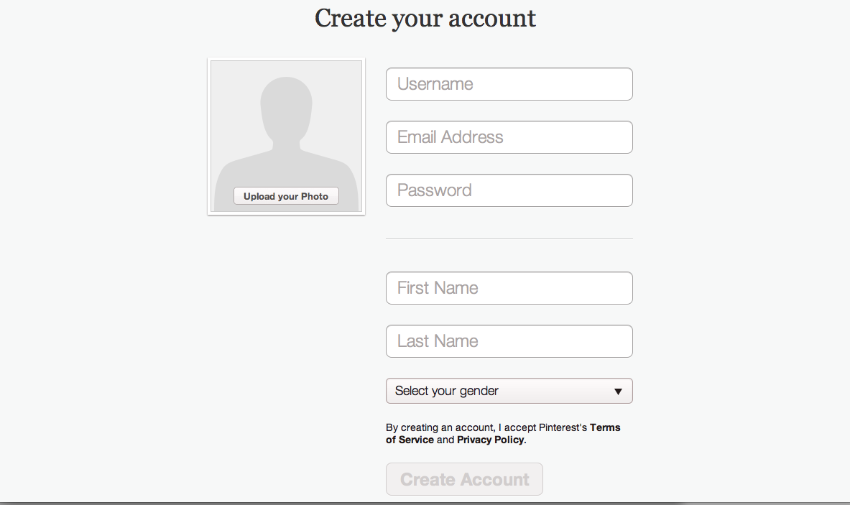

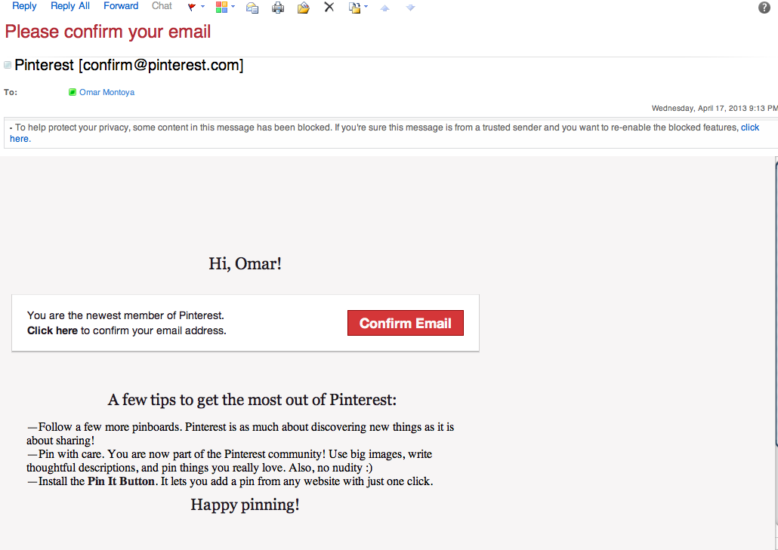
STEP 4: Log into your email account, find the confirmation email, and click on “Confirm Email.”

STEP 5: Now that you have your account set up, you’re ready to create a board! To create a board, hover over your name at the top of the page until the drop-down menu opens. Then select “Your Boards” from the menu.
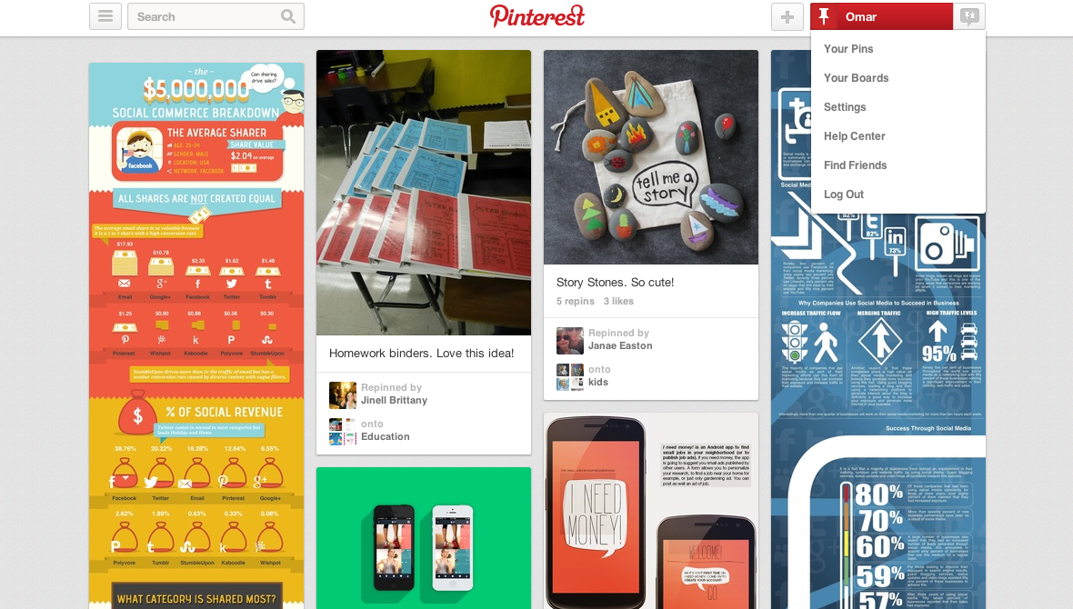

STEP 6: From the new page, click on “Create a board.” Then, fill in the required information.

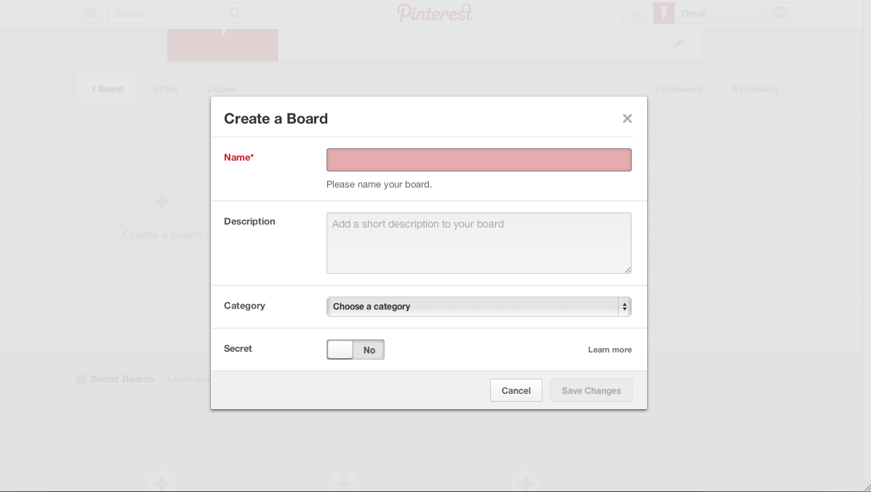

STEP 7: You’ve now created your board and are ready to start pinning! Click on “Add a pin” to find quotes, images, etc. to pin to your board. You have three options for pinning:
- From computer
- From a website
- From Pinterest

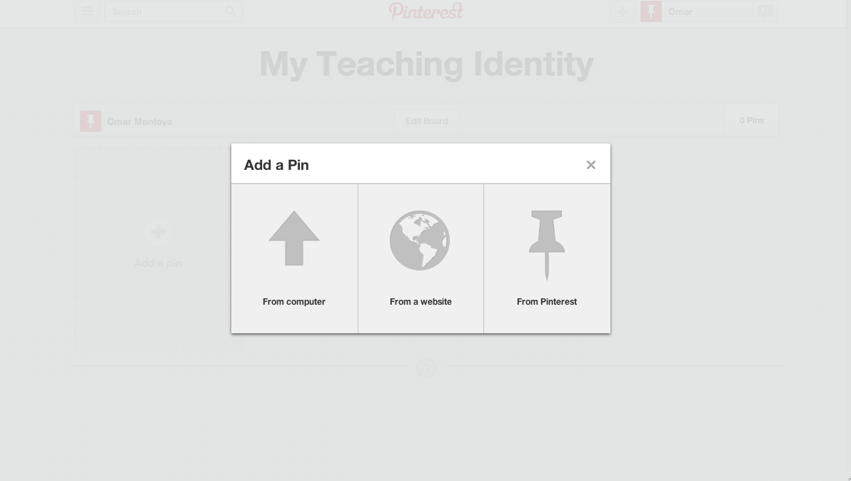
Choose an option and find something to pin. Have fun!

