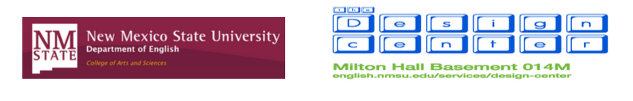

Girlhood Remixed Technology Camp 2015

Camp Registration Payment

The registration per camper is $20. This includes lunch every day, snacks, a t-shirt, and a flashdrive with copies of all camp projects. Registration payment must be received by June 27 in order for us to guarantee a spot for your camper.

You can write a check or money order to NMSU English Department with the memo line Girlhood Remixed Technology Camp. No cash is accepted.

Please also fill out the information below so we can be sure to keep track of your payment.

Camper’s Name: _________________________________________________

☐ Check name on check ___________________________________ check number ________
☐ Money Order

Date of payment: __________

GRTC 2015 SCHOLARSHIP

We are happy to announce that a $20 scholarship will be available to one of this summer's campers to cover the camp registration fee.

To apply, campers must write a 1-page answer to this question: How does technology impact your identity as a 'tween girl?

Answers must be emailed to Camp Director Jen England at jengland@nmsu.edu by May 27 at 5 p.m. The winner will be selected by Jen in consultation with camp volunteers and informed by June 10.

