STEP 1: Go to twitter.com. Complete the “New to Twitter? Sign up” box, and then click on the “Sign up for Twitter” button.

STEP 2: Choose a username and make any changes to your basic account information. Then, click the “Create my account” button.

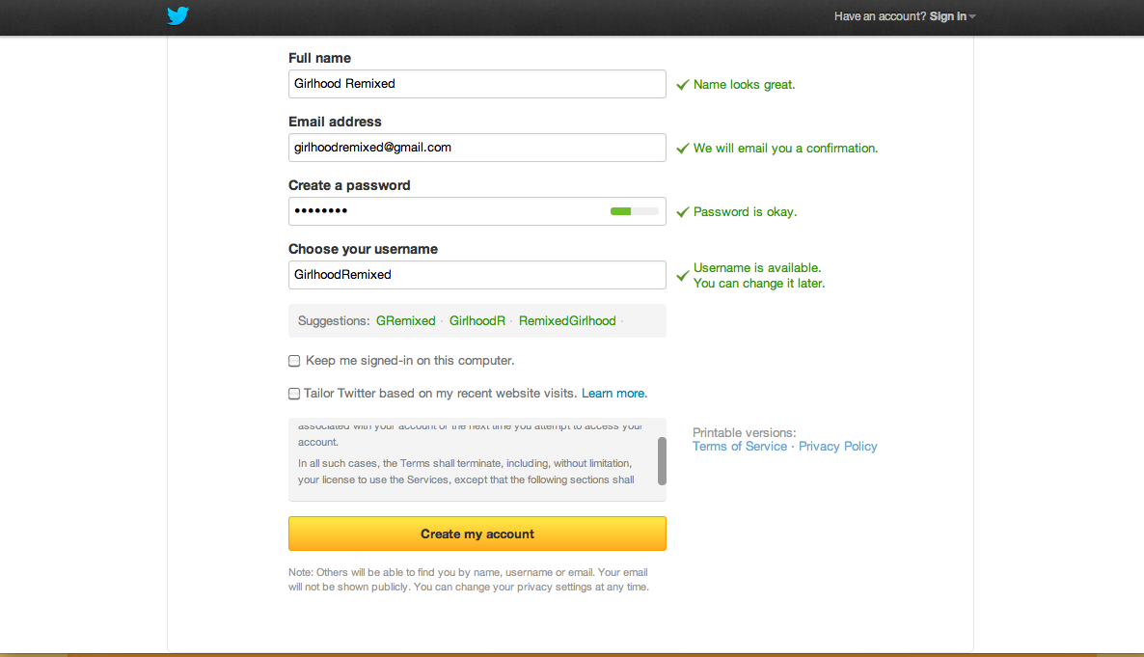

STEP 3: Complete the steps Twitter asks you to. During these steps you will be able to choose people to “follow.” When you follow someone you will gain access to their tweets and will be able to reply and re-tweet their posts.
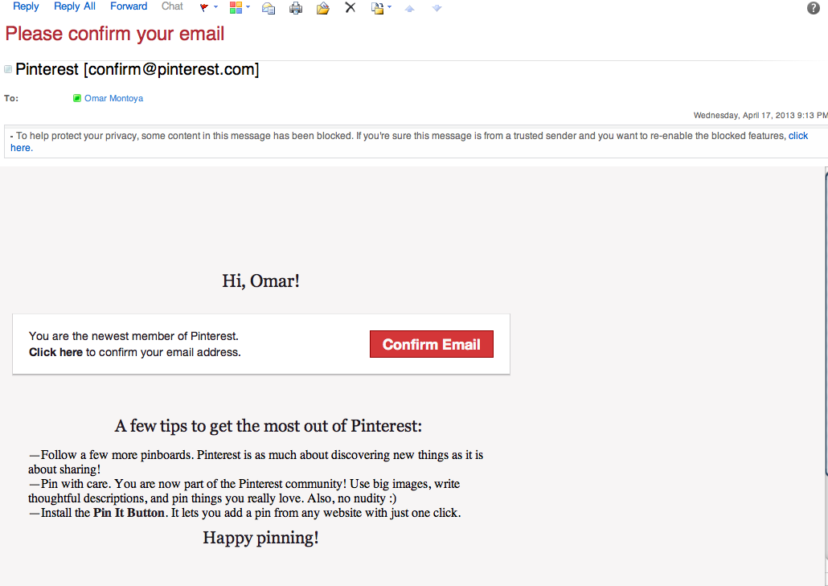

Once you’ve begun following people, you will be asked to create your profile by uploading an image and writing a short bio. When you’re finished, click the “Done” button.

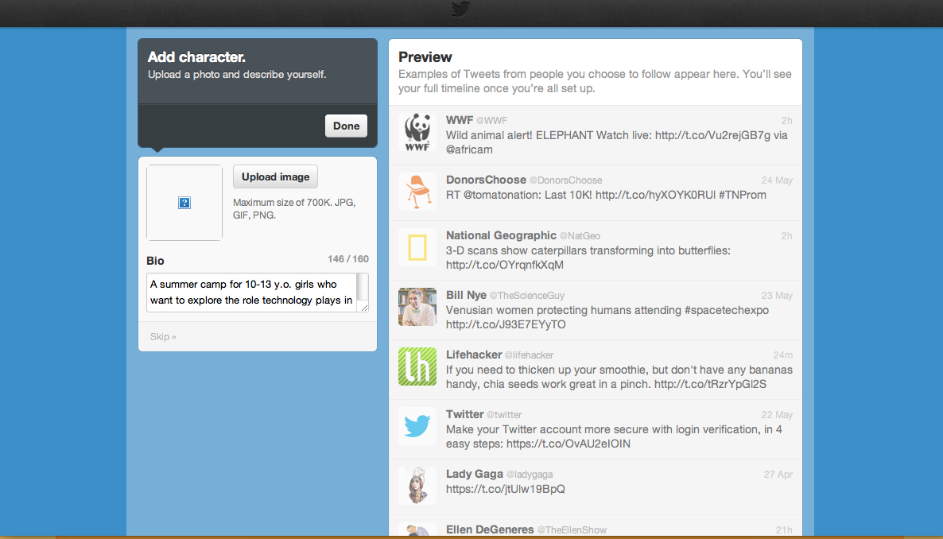

STEP 4: You’re almost ready to start tweeting! First, go to your email account and find the confirmation email from Twitter. Click on the “Confirm your account now” button.
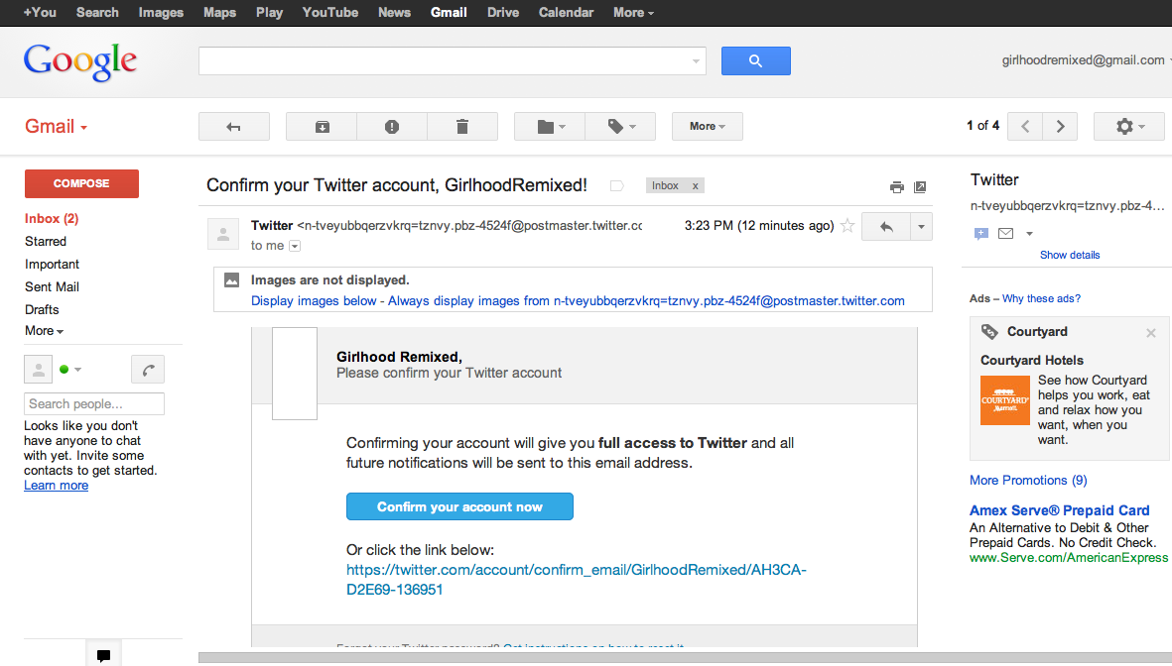

This will take you back to your new Twitter account homepage, which will look something like this:

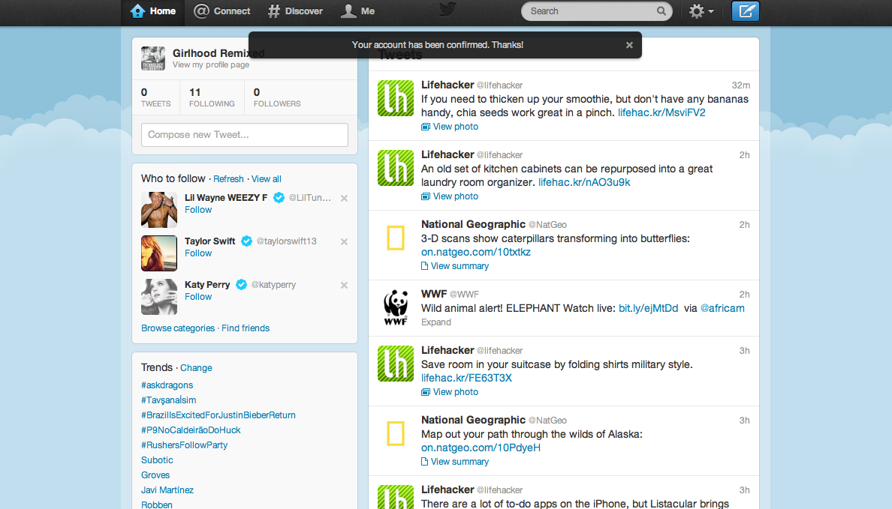

STEP 5: Now you’re all set to tweet. To create a tweet, go to the top of the homepage and click the blue button that looks like a feather pen and piece of paper (it’s on the right-hand side). Then, type your tweet in 140 characters or less. When you’re done, click on the “Tweet” button.

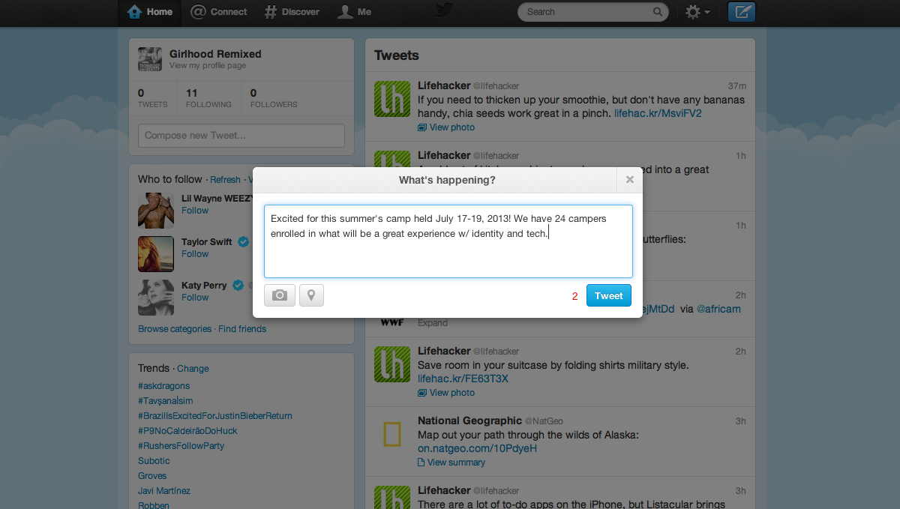

You’ll see your new tweet at the top of your homepage:

STEP 7: Be sure to check out your followers, add new followers, and respond to or re-tweet what they say. To do this, hover over a follower’s tweet and select one of those options. Be sure to click the blue button when you’re ready.

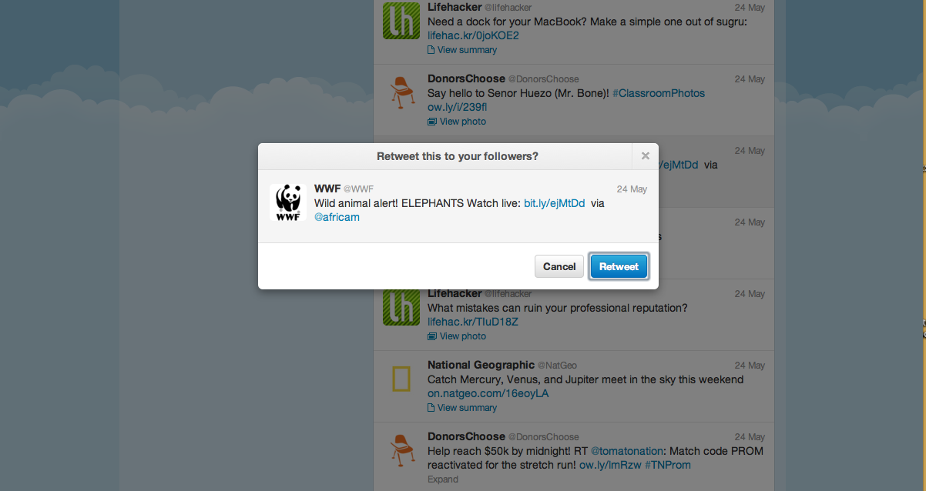
Enjoy exploring Twitter!

