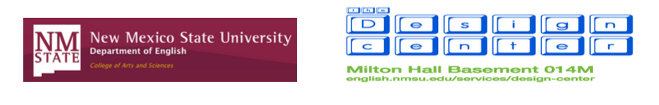

Girlhood Remixed Technology Camp 2015

Dear Parents and Guardians,

We would like to officially extend an invitation for your child to participate in what we hope is a fun and exciting opportunity for young women interested in expanding both their knowledge of and interest in technology. Your child has been selected as one of 14 participants for the Girlhood Remixed Technology Camp to be held at New Mexico State University July 27-31, 2015.

As a part of this camp, your child will be producing various new media projects (websites, digital movies, images, etc.) as well as learning more about computers and technology and ways girls can critically and carefully craft their own identities in online spaces. Your child also will be participating in discussions about representations of women in the media and activities related to body and mind positivity.

In order to begin final preparations for the camp, we need some information from our campers. Enclosed are materials to be read, filled out, signed, and returned so we can make the camp most beneficial to those enrolled. Additionally, there are some materials intended to provide more information to you and your child about the specifics of the camp including information on the curriculum and the closing reception for family and friends.

Enclosed are the following:

To be returned:
- Camp registration payment form
- Emergency contact information
- Permissions consent form
- Code of Conduct
- Technology Knowledge Inventory
- T-shirt size form

To keep:
- Preliminary camp schedule
- Campus map

Please mail the enclosed “to be returned” forms and registration payment in the included self-addressed envelope by June 27 so we may begin final preparations for the camp. If the necessary materials are not returned by June 27, your child’s spot in Camp may be forfeited and given to a child who is on the wait list. We do this to ensure fairness to all interested campers.
Below you will find some additional information about the camp:

Check In. Campers should arrive with their parent or guardian at Clara Belle Williams Hall at 8:30 a.m. on Monday, July 27 to check in. There will be a very short orientation for parents with camp staff available to answer questions. All other days, campers will arrive at the Design Center (Milton Hall Basement) at 9 a.m. For parking and directions to these locations, see the enclosed campus map.

Check Out. Camp ends each day at 5 p.m. Parents and guardians can pick up their children from the parking lot stretching between Clara Belle Williams Hall, Milton Hall, and Barnes & Noble. The parking lot is also marked on the enclosed map.

Meals. Lunch and snacks are provided every day; we will also provide light refreshments for the Closing Ceremony on Friday. However, girls may wish to bring along some snacks, water, or spending money to cover any incidentals or munchies. Meals and snacks will be served on campus with the exception of a trip to Sweet CeCe’s Frozen Yogurt & Treats (located on East University Avenue) on Thursday, July 30.

Closing Ceremony. Parents, guardians, family, and friends are invited to join us at 6 p.m. on Friday, July 31 for a Camp Closing Ceremony. We will showcase the campers’ work and present each child with a certificate. The ceremony takes place in the Health and Social Services (HSS) Auditorium room 101A, which is located near Clara Belle Williams Hall. For parking and directions, see the enclosed campus map.

If you have any questions or need further information, please feel free to contact Camp Director Jen England at jengland@nmsu.edu or 419-571-2296. Also, check for updates on the Camp’s website at www.girlhoodremixed.wix.com/home.

We look forward to meeting you and your children in July and to spending time learning alongside the next generation of online girls.

Sincerely,

Jen England and the Girlhood Remixed Technology Camp 2015 Staff

